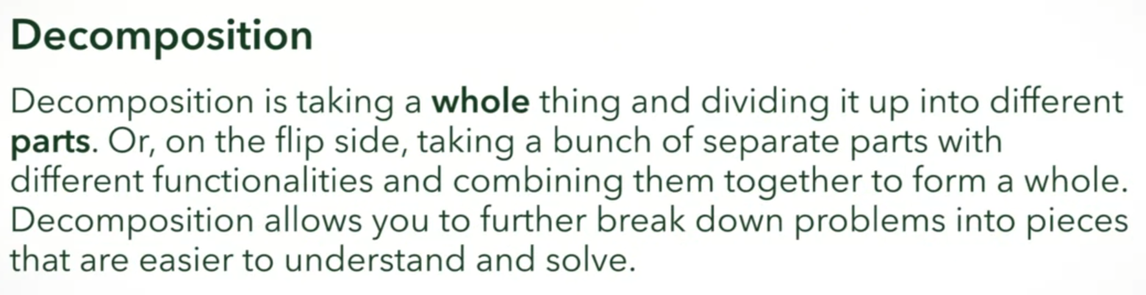

What are some objects that you might get by **decomposing** a Car?

car door, car seat, steering wheel

Correct

You may have identified many objects! Perhaps wheels, a steering wheel, a windshield, a gas pedal. If you are interested cars, you may have identified an engine or a fuel pump.

The objects you choose to use in your software will depend on the **context!**

Fixed/Dynamic Parts of a Car

Fixed: doors, seat

Dynamic: passengers

Which of these car "parts" has a dynamic number?



Passengers



Tires



Steering wheel



Engines

Correct

A car can accommodate a **dynamic** number of passengers.

**Parts containing parts**

Returning to our example of a car, can you think of another example of a part that contains another part?

steering wheel contains horn, fuel tank contains fuel

Correct

You could have come up with many answers! Here are some examples:

A headlamp contains a bulb.

The wheel contains a rim and a tire.

An engine contains many things, like pistons and spark plugs.

**Lifetimes**

Consider the lifetime of a car. Can you think of one part that has a closely-related lifetime, and one part that does not?

There are many examples. The engine typically has the same lifetime as the car - when the engine goes, so does the car! The wheels, on the other hand, are replaced many times over the course of a car's life.

**Sharing**

Sharing between classes

**Decomposition points to address**

